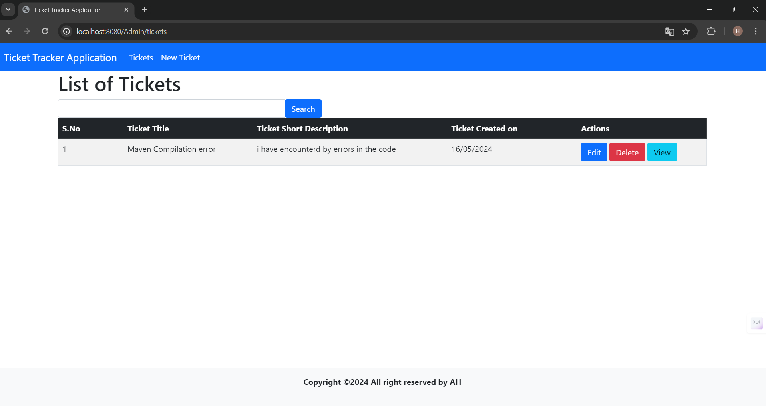

**1) Home Screen with data and action buttons (New Ticket, Edit, Delete, View)**

**2.Create New Ticket**

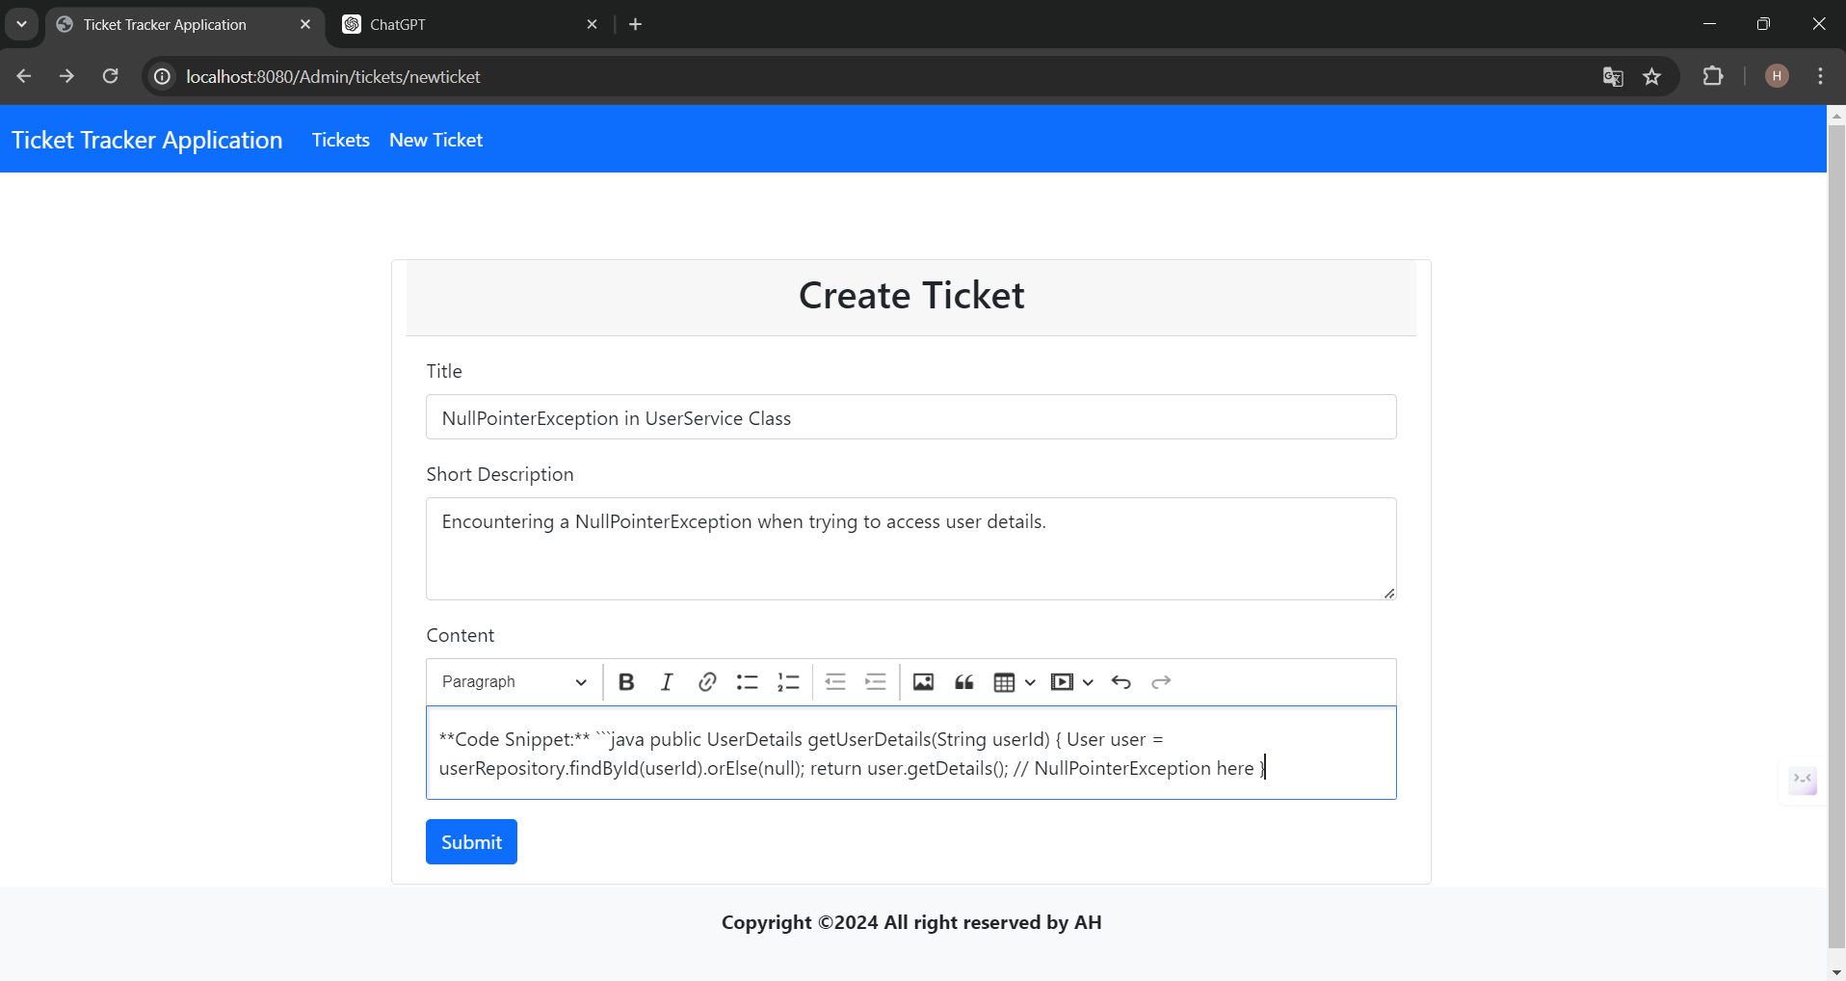

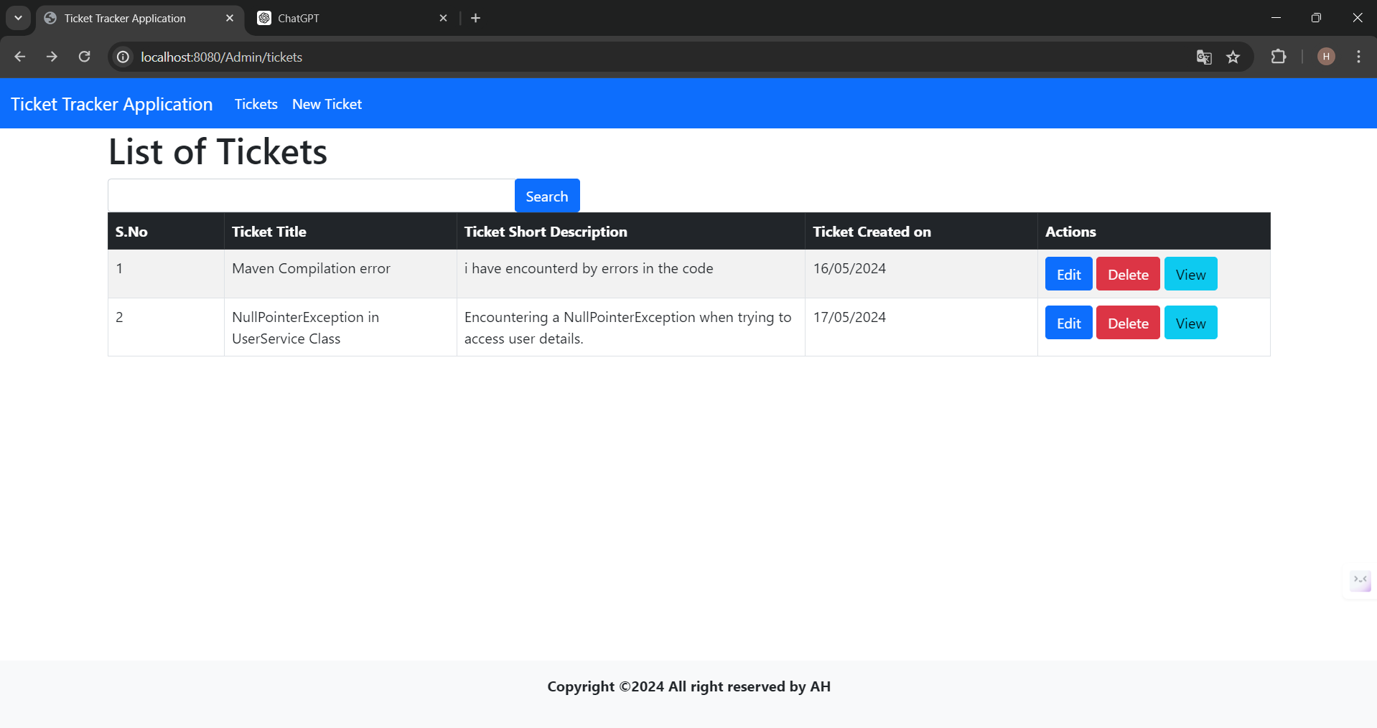

**3. List Of Tickets**

**4.Before Editing Ticket**

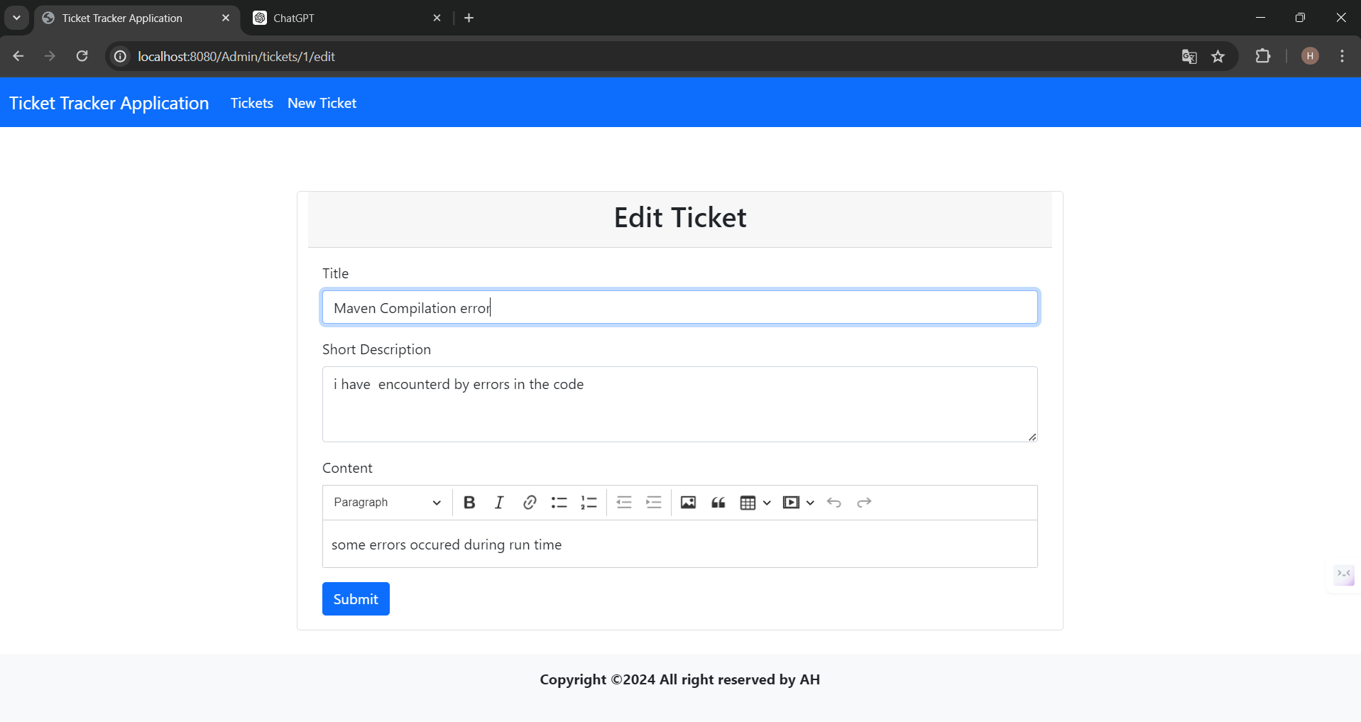

**5.After Editing Ticket**

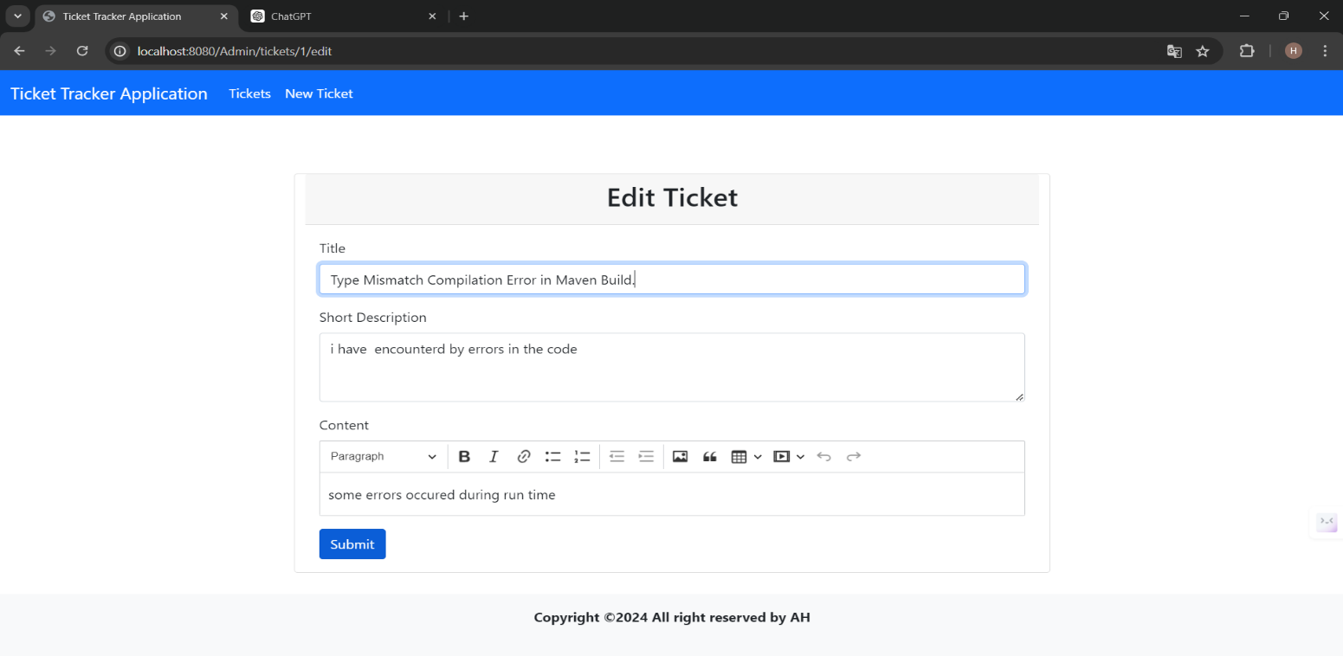

**6.List Of Edited Ticket**

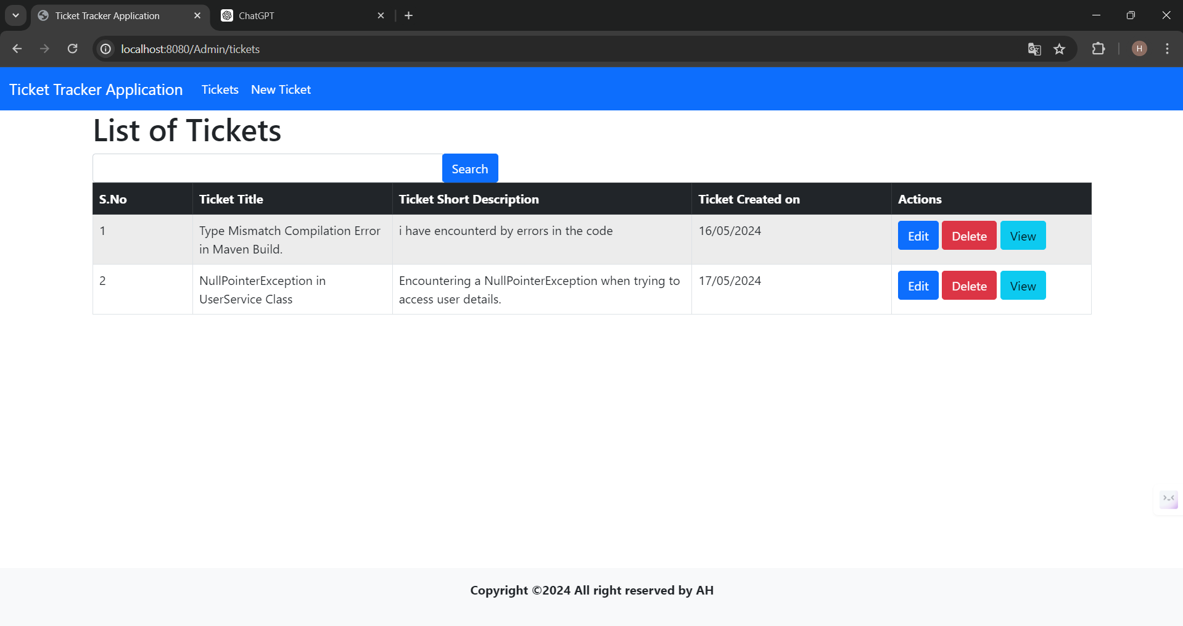

**7.View Ticket Details**

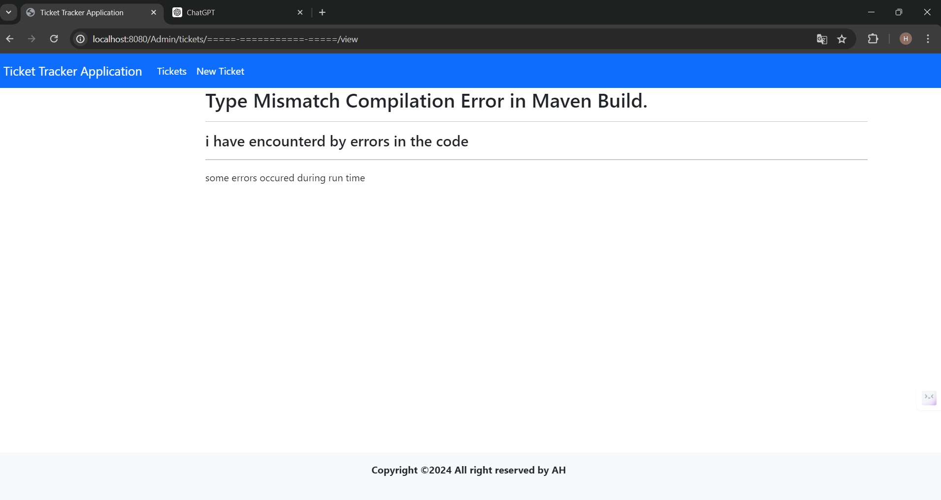

**8.Delete Ticket**

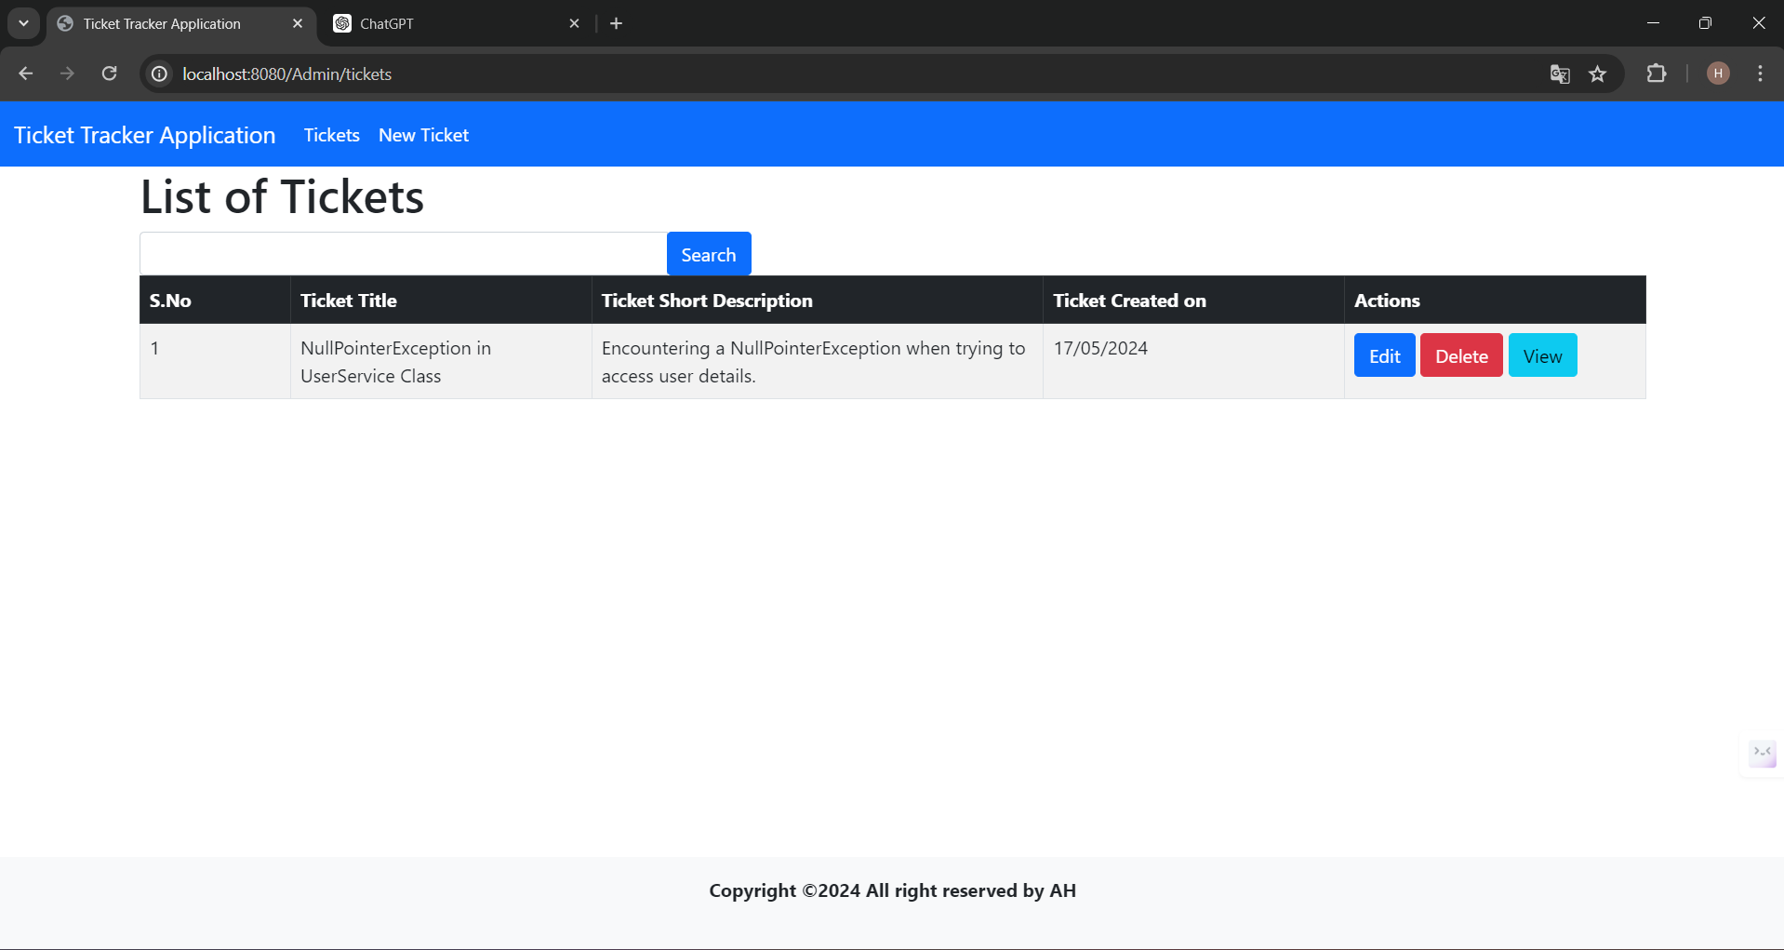

**9.Search Functionality**

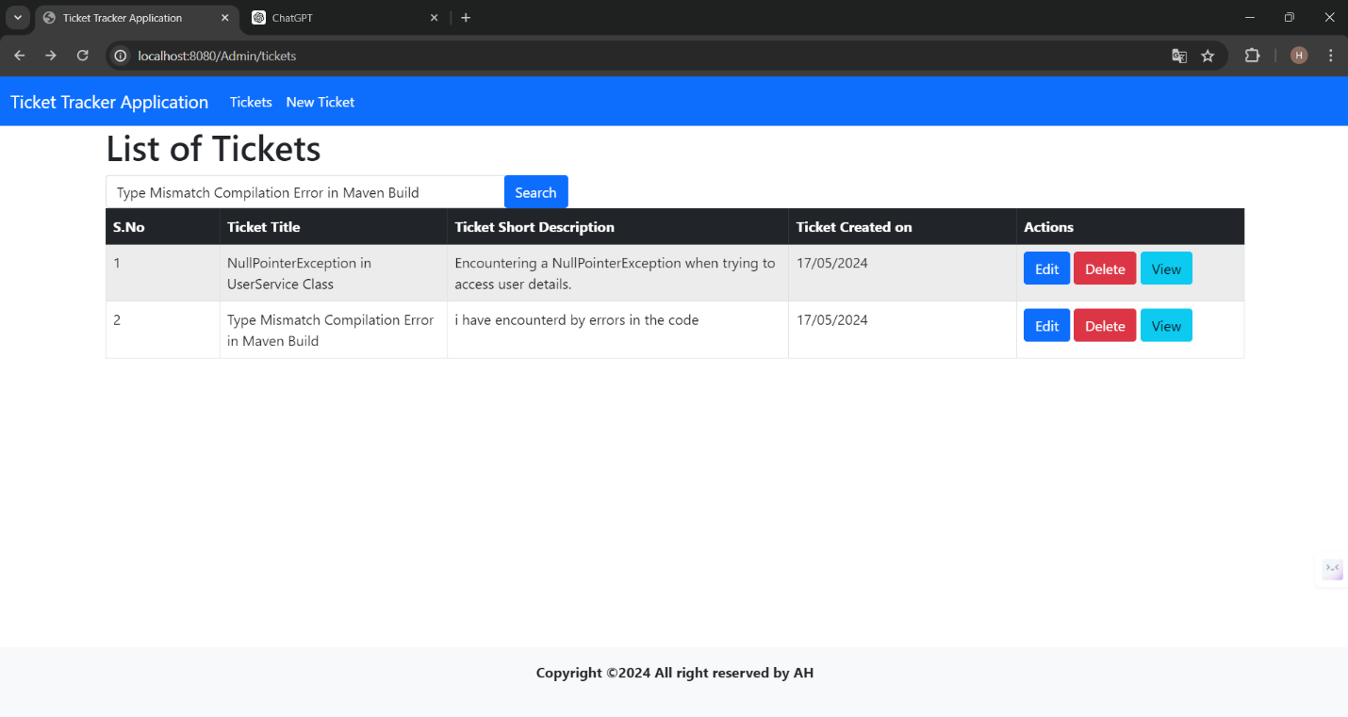

**10.After Seraching Ticket**

